Graded Coding Assignment 4 Solutions

create table PASSENGER

(

Passenger_name varchar(20),

Category varchar(20),

Gender varchar(20),

Boarding_City varchar(20),

Destination_City varchar(20),

Distance int,

Bus_Type varchar(20)

);

create table PRICE

(

Bus_Type varchar(20),

Distance int,

Price int

);

insert into passenger values('Sejal','AC','F','Bengaluru','Chennai',350,'Sleeper');

insert into passenger values('Anmol','Non-AC','M','Mumbai','Hyderabad',700,'Sitting');

insert into passenger values('Pallavi','AC','F','panaji','Bengaluru',600,'Sleeper');

insert into passenger values('Khusboo','AC','F','Chennai','Mumbai',1500,'Sleeper');

insert into passenger values('Udit','Non-AC','M','Trivandrum','panaji',1000,'Sleeper');

insert into passenger values('Ankur','AC','M','Nagpur','Hyderabad',500,'Sitting');

insert into passenger values('Hemant','Non-AC','M','panaji','Mumbai',700,'Sleeper');

insert into passenger values('Manish','Non-AC','M','Hyderabad','Bengaluru',500,'Sitting');

insert into passenger values('Piyush','AC','M','Pune','Nagpur',700,'Sitting');

select * from passenger;

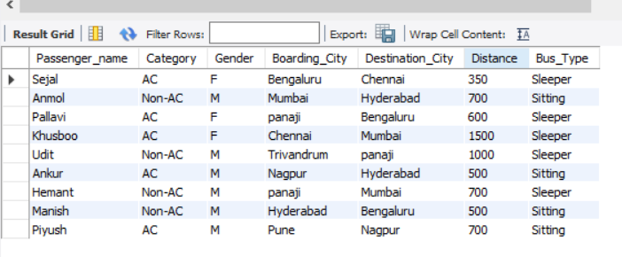

INSERT INTO price values ('Sleeper', 350,770);

INSERT INTO price values ('Sleeper', 500, 1100);

INSERT INTO price values ('Sleeper', 600, 1320);

INSERT INTO price values ('Sleeper', 700, 1540);

INSERT INTO price values ('Sleeper', 1000, 2200);

INSERT INTO price values ('Sleeper', 1200 ,2640);

INSERT INTO price values ('Sleeper', 1500, 2700);

INSERT INTO price values ('Sitting', 500, 620);

INSERT INTO price values ('Sitting', 600, 744);

INSERT INTO price values ('Sitting', 700 ,868);

INSERT INTO price values ('Sitting', 1000 ,1240);

INSERT INTO price values ('Sitting', 1200, 1488);

INSERT INTO price values ('Sitting', 1500, 1860);

select * from price;

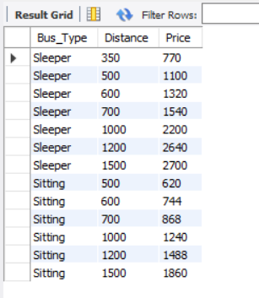

/* 3) How many females and how many male passengers travelled for a minimum distance of 600 KM s?*/

select Gender, COUNT(Gender) as numberOfPassenger

from passenger

where Distance >= 600

GROUP BY Gender;

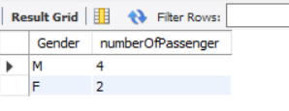

/*4) Find the minimum ticket price for Sleeper Bus. */

SELECT * FROM price where bus_type = 'sleeper'

having min(price);

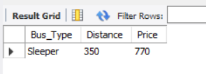

/*5) Select passenger names whose names start with character 'S' */

select passenger_name

from passenger

where passenger_name like 'S%' ;

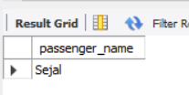

/*6) Calculate price charged for each passenger displaying Passenger name, Boarding City,

Destination City, Bus_Type, Price in the output */

select passenger.Passenger_Name, passenger.Boarding_City,

passenger.Destination_City, passenger.Bus_Type, price.Price

from passenger , price

where price.Distance=passenger.Distance and passenger.bus_type = price.bus_type;

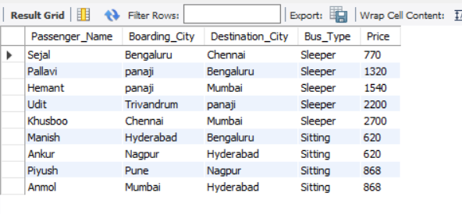

/*7) What are the passenger name/s and his/her ticket price who travelled in the Sitting bus

for a distance of 1000 KM s */

select passenger.Passenger_Name, price.Price

from passenger , price

where passenger.Bus_Type ='Sitting' and passenger.Distance = 1000 and price.bus_type='sitting' and price.Distance=1000;

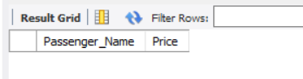

-- Since there is no result for 1000 Kms to ensure the output for 500 KMs test.

select passenger.Passenger_Name, price.Price

from passenger , price

where passenger.Bus_Type ='Sitting' and passenger.Distance = 500 and price.bus_type='sitting' and price.Distance=500;

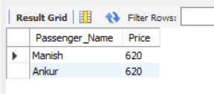

/*8) What will be the Sitting and Sleeper bus charge for Pallavi to travel from Bangalore to

Panaji?*/

select price.Bus_Type,price.Distance,price.Price

from price

where price.distance in (

select distance from passenger

where (Boarding_City = 'Bengaluru' and Destination_City = 'Panaji') or (Boarding_City = 'Panaji' and Destination_City = 'Bengaluru') and Passenger_name = 'Pallavi')

having price.Bus_Type='Sleeper' or price.Bus_Type='Sitting' ;

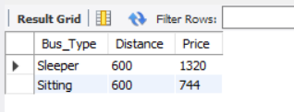

/*9) List the distances from the "Passenger" table which are unique (non-repeated

distances) in descending order.*/

-- the below will show all the distance once

SELECT DISTINCT distance FROM passenger ORDER BY Distance desc;

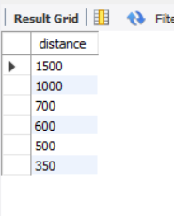

-- the below will remove the duplicated distance; which are being only once that distance alone will be displayed.

-- ex., 500 & 700 has duplication so that will not be displayed.

select Distance from passenger

where passenger.Distance not in (

SELECT Distance

FROM passenger

GROUP BY Distance

HAVING COUNT(Distance) > 1

) order by Distance DESC;

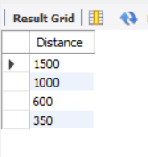

/*10) Display the passenger name and percentage of distance travelled by that passenger

from the total distance travelled by all passengers without using user variables */

SELECT Passenger_name, Distance * 100.0/ (SELECT SUM(Distance) FROM passenger)

FROM passenger ;

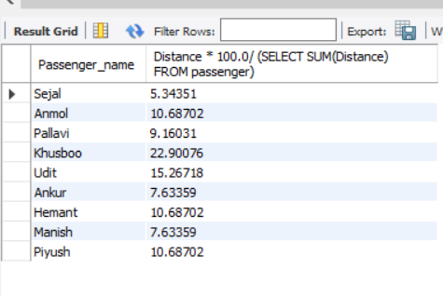

/*11) Display the distance, price in three categories in table Price

a) Expensive if the cost is more than 1000

b) Average Cost if the cost is less than 1000 and greater than 500

c) Cheap otherwise*/

DELIMITER &&

CREATE PROCEDURE PROC()

BEGIN

SELECT price.distance,price.price,

case

when price.price > 1000 then 'Expensive'

when price.price < 1000 and price.price > 500 then 'Average Cost'

ELSE 'Cheap'

end as Output from price ;

END &&

DELIMITER ;

call PROC();

